# Activity: Set up a common date table

## **Introduction**

In this lesson, you’ve explored the significance of a common-date table in a data model. You’ve also reviewed the process for creating a common-date table in your models using both DAX and M language in Power BI

In this exercise, you must apply your knowledge of DAX and Power Query to generate a date dimension table within a data model.

* You’ll walk through the steps to create a date dimension table using DAX in Power BI.
* The goal is understanding how Power BI allows you to control your data model according to your analytical needs.

## **Case study**

Adventure Works collects data from a range of different sources and collates this data in a data model that contains the following tables:

* Sales
* Salesperson
* Products
* Reseller
* And Region

However, there’s no date dimension table in these datasets. This makes it difficult to perform time intelligence analysis. Help Adventure Works to create a common-date table in its data model using DAX.

## **Step 1: Download and launch the Power BI project file AdventureWorks.pbix.**

* Adventure Works provides a Power BI project file called AdventureWorks.pbix. that contains the required data model. You must download this dataset and load it into Power BI.

## **Step 2: Observe the data model and create a date dimension table using DAX.**

1. Access the Model tab in Power BI to view the data model’s tables. Note that there is no date dimension table present.

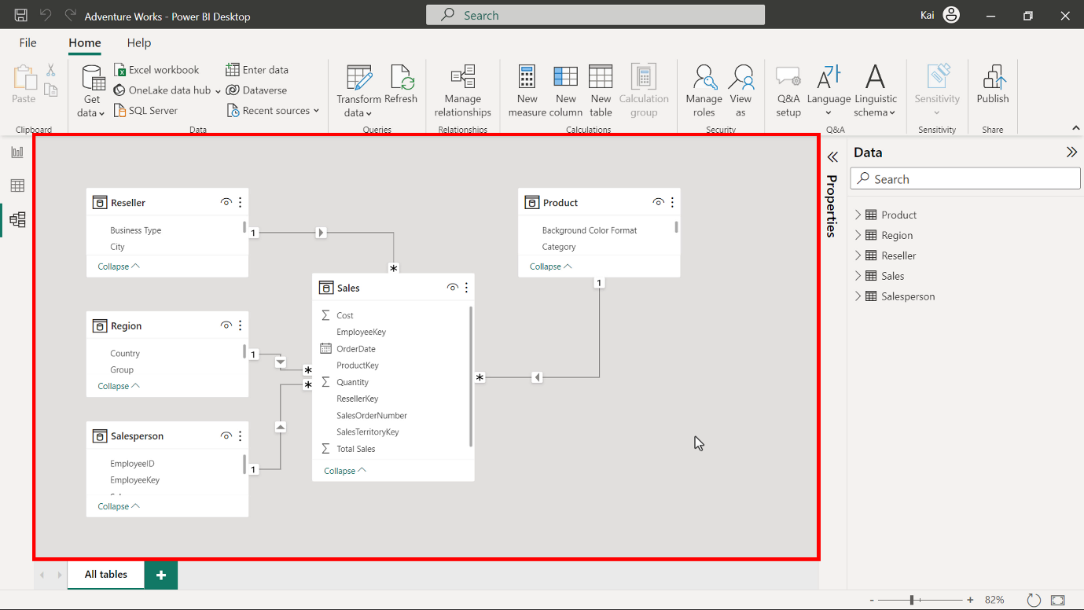

1. Navigate to the Home tab and select Newtable from the calculations group. In the formula bar, input the following DAX code using the CALENDAR function to create a table with a single column containing dates.

1

In the CALENDAR function, you need to specify the start and end dates. The Adventure Works sales data starts in 2017 and ends in 2020. The start date must occur on or before the date column of the dataset. The end date must be on or after the end date of the dataset. Execute the code to generate a table with a single date column containing a list of dates with time.

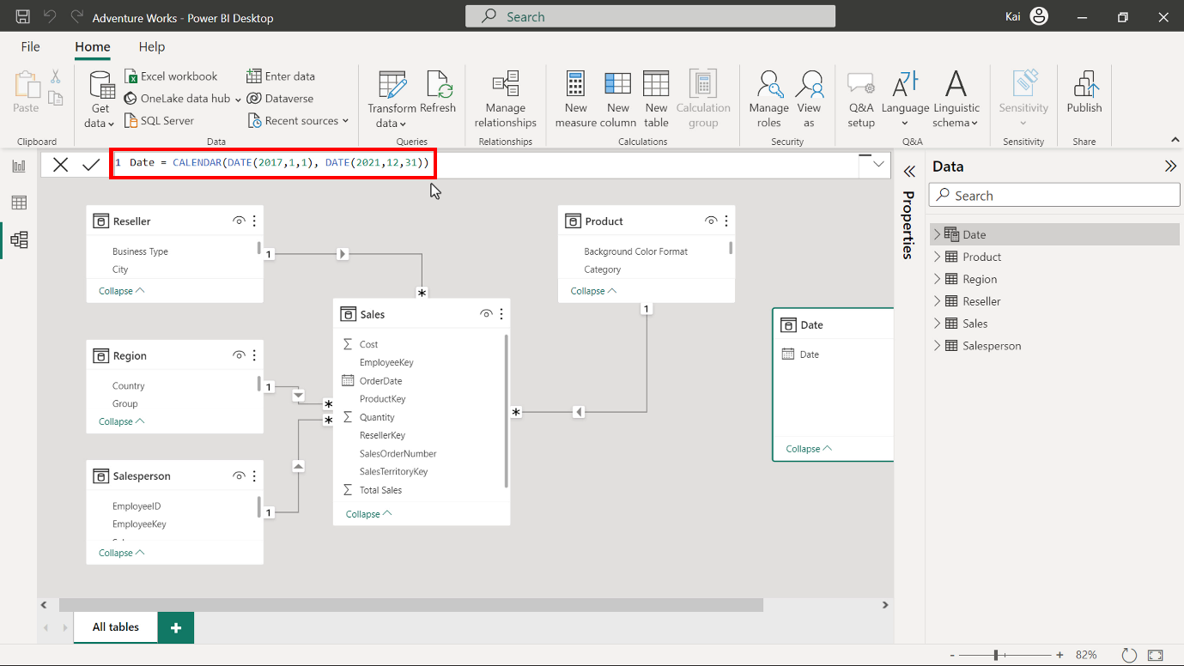

1. Now you must format and configure the table. Rename the column as Date and format the column as Date data type. Select the Date column and navigate to the Column tool tab.

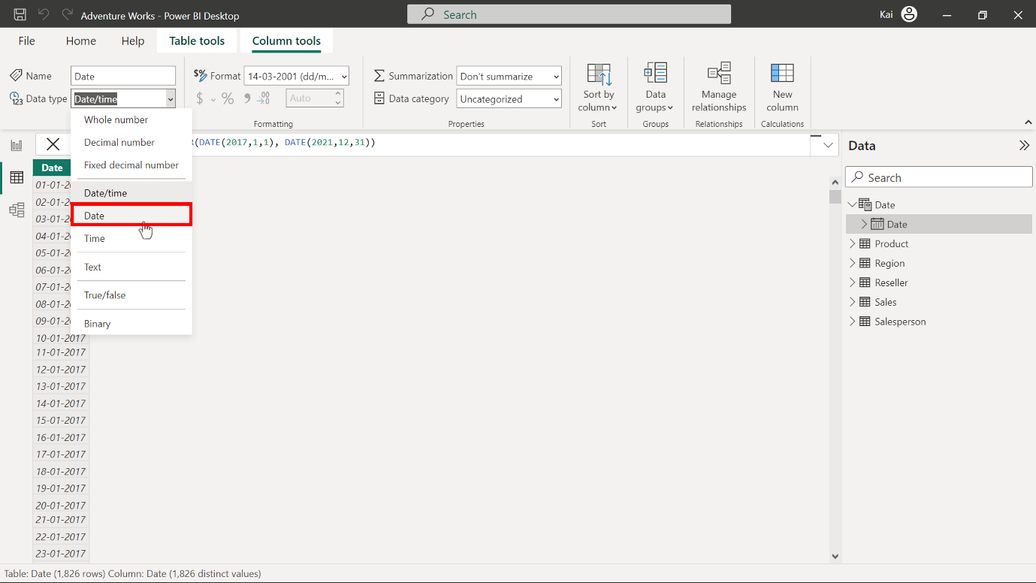

Select the appropriate date format from the format drop-down list of options.

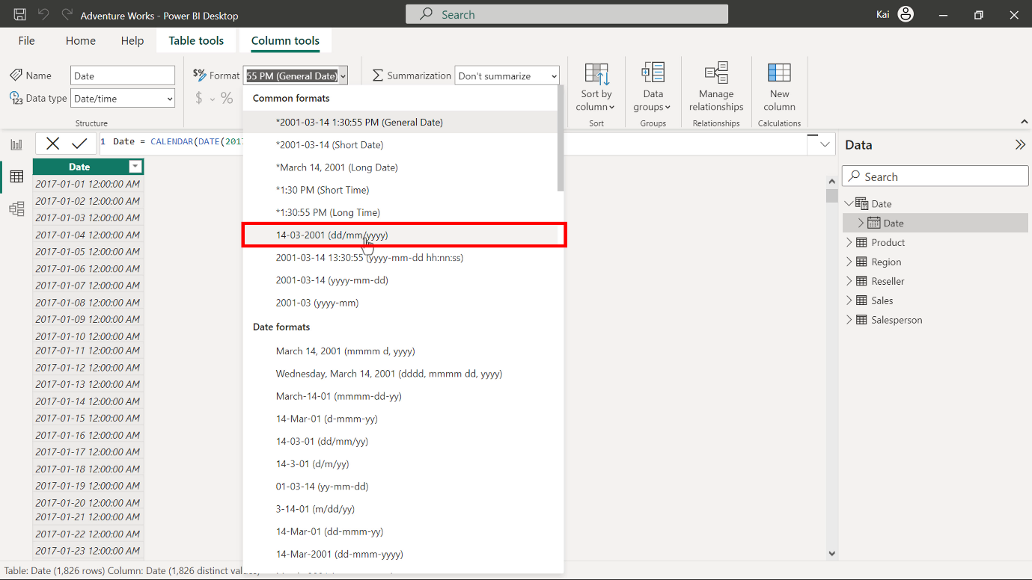

1. Next, you must populate the date dimension table with related columns like year, month number, month, day of the week, and week number. Select New column from the Calculations group of the Column tools tab to expand the DAX formula bar. Then enter the following DAX codes, one in each step.

1

2

3

4

5

* The date-related functions in the above DAX formulas, like YEAR, MONTH, WEEKNUM, WEEKDAY extract the relevant information from the date column of the table.

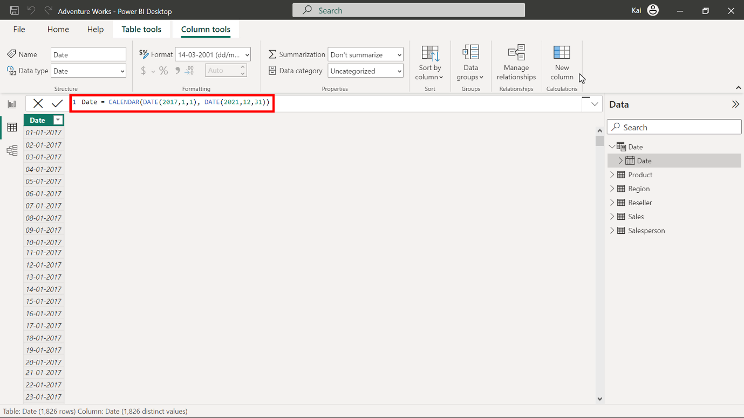

Copy and paste the following code into the formula bar to add the YEAR data.

1

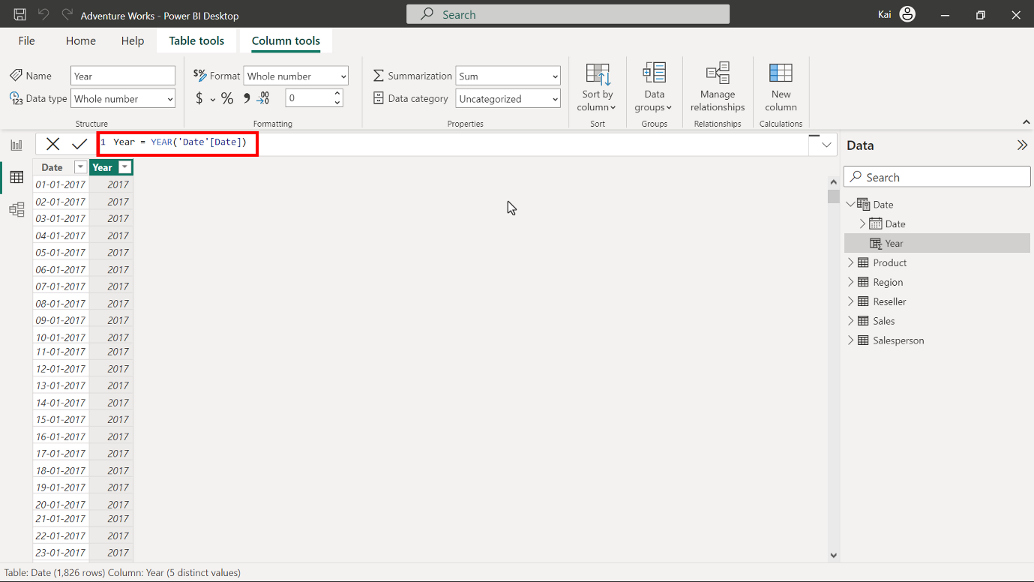

Copy and paste the following code into the formula bar to add the MONTH data.

1

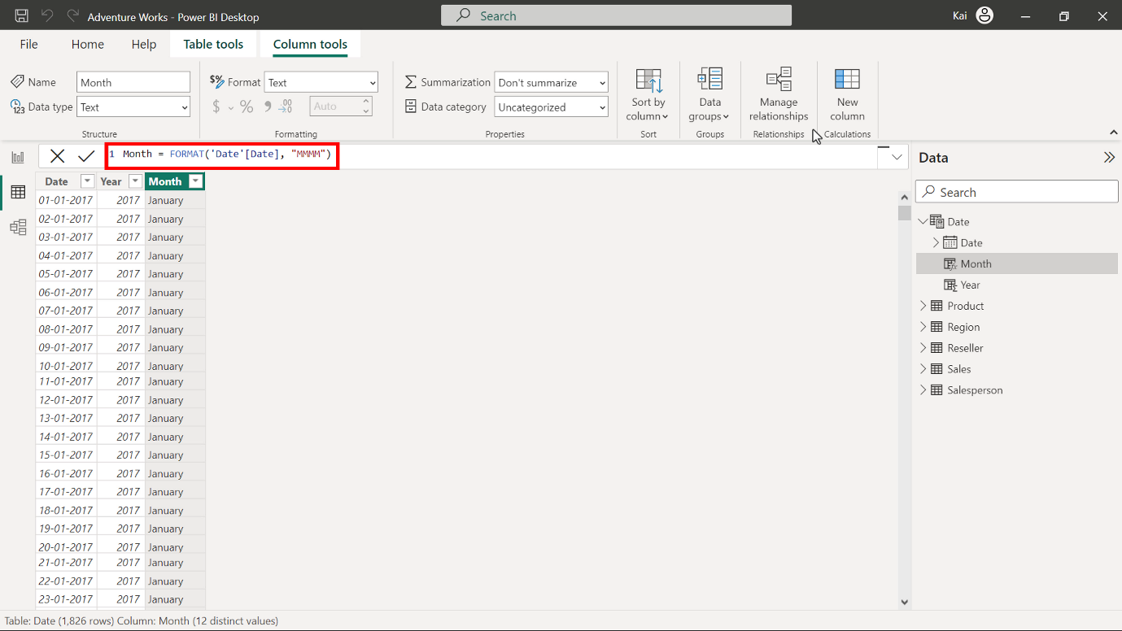

Copy and paste the following code into the formula bar to add the DAY OF THE WEEK data.

1

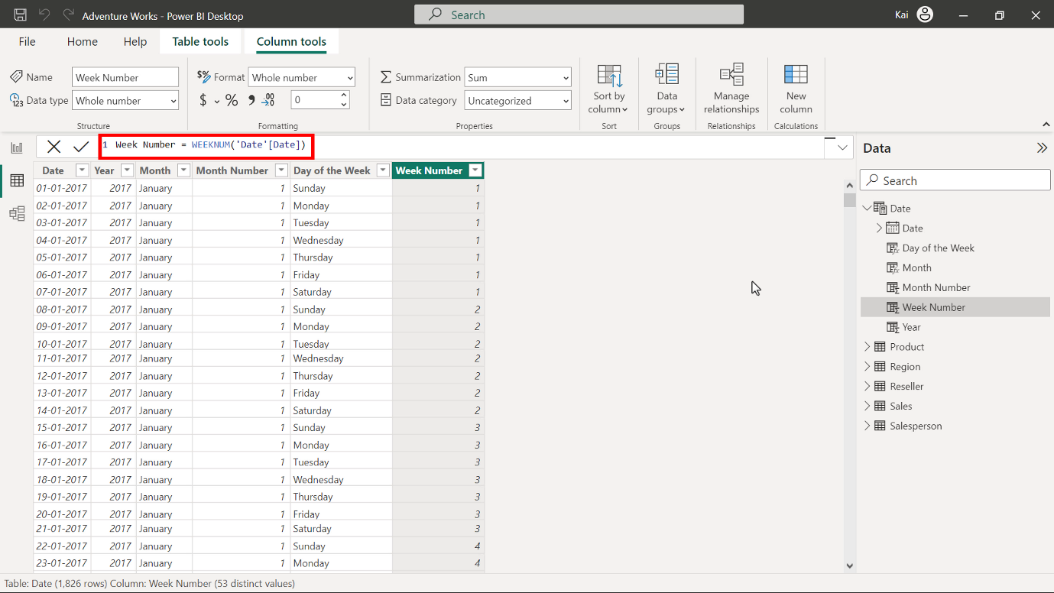

1. Next, mark the newly created date dimension table as a date table. Select the ellipses on the right side of the date table and select Mark as date table from the drop-down list of options. This opens a dialog box that states Mark as date table.

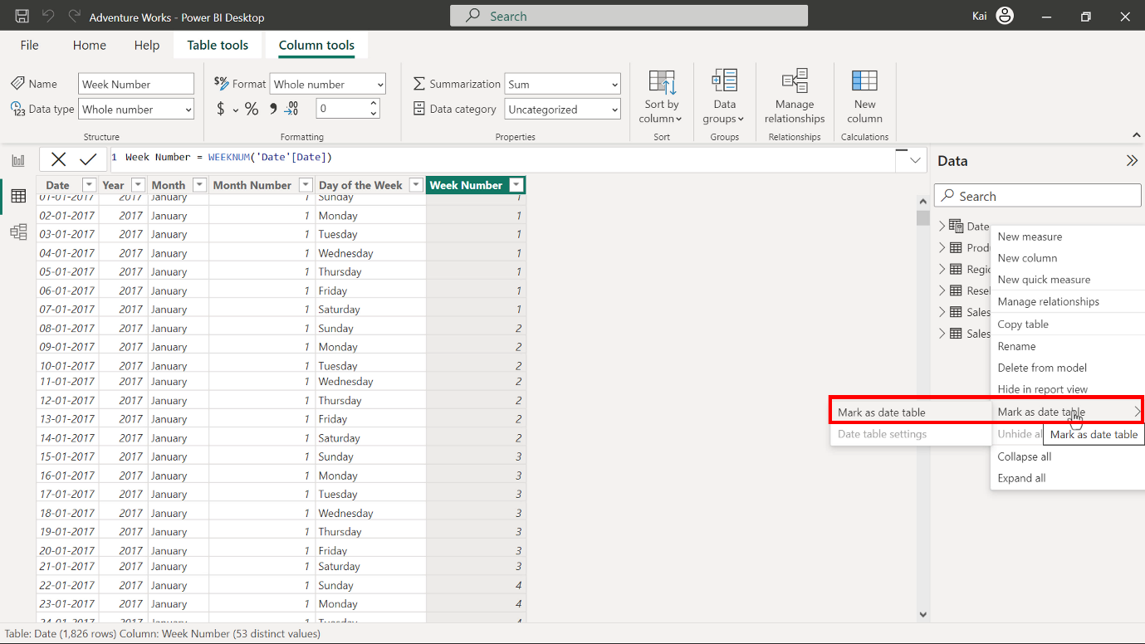

Select the Date option from the Date column drop-down menu. Once you select the date column, it displays a message Validate successfully. Select OK.

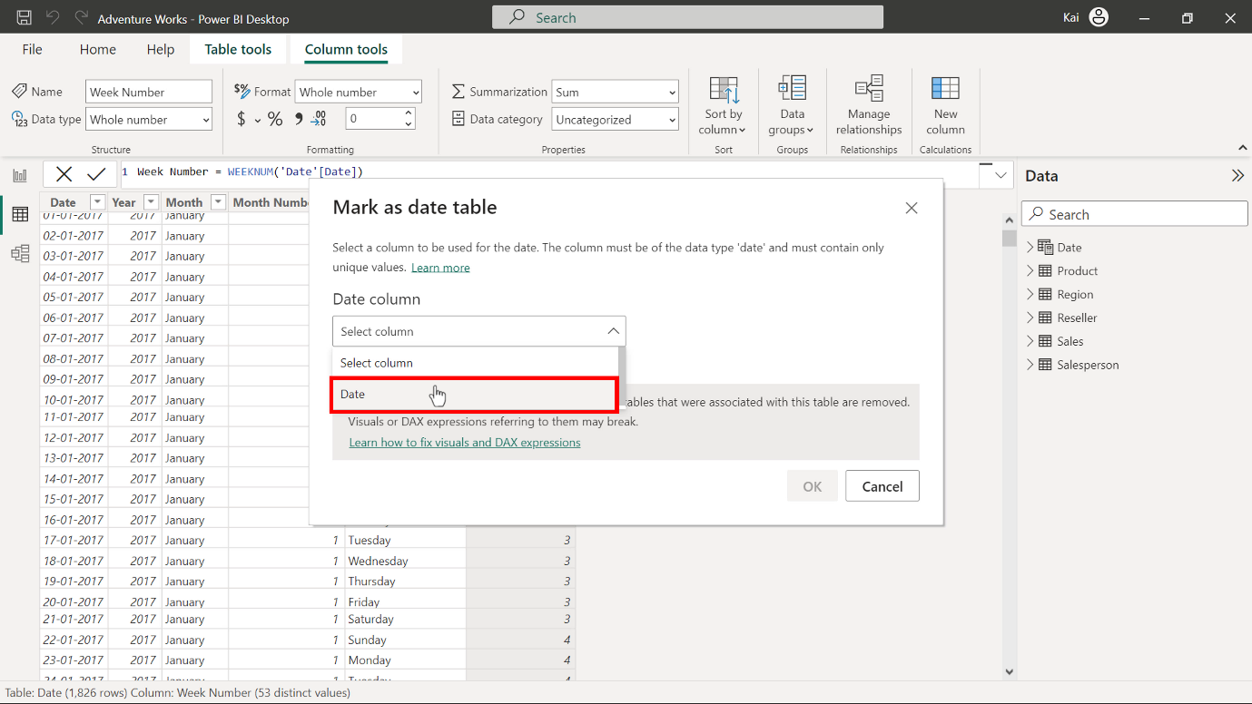

1. Next, you must establish a relationship between the Date and the Fact table in the data model. A Date dimension table is ready for analysis and reporting in your data model.

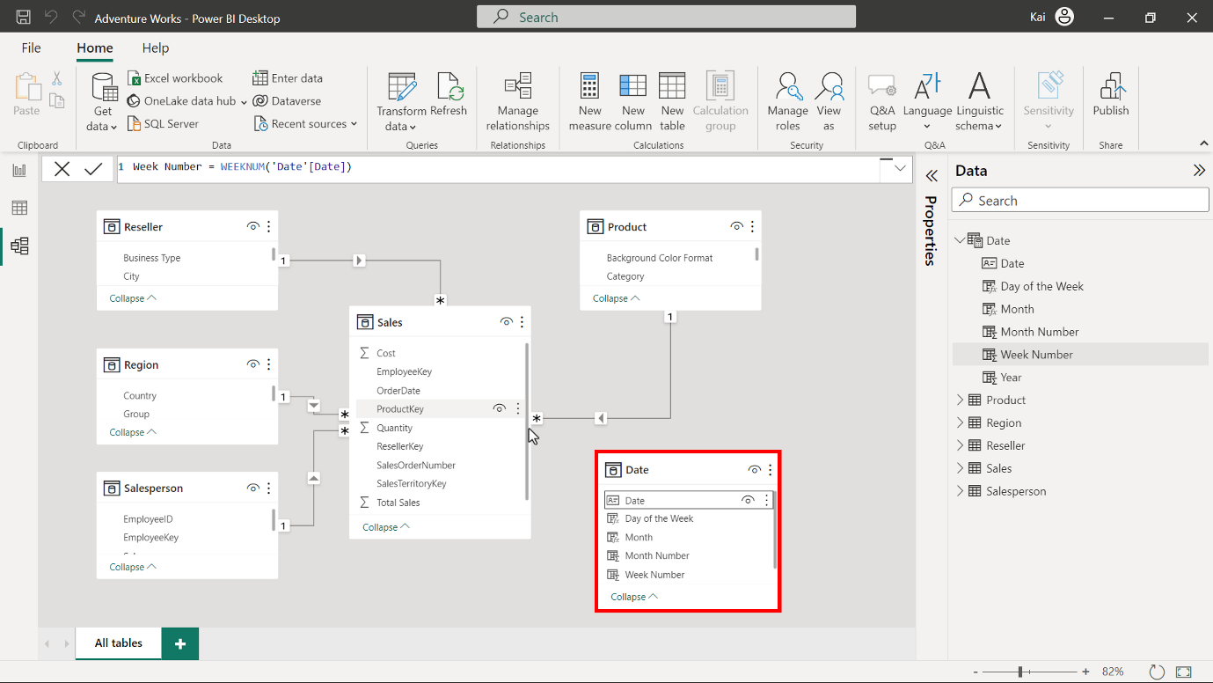

## **Step 4: Save the project.**

Save the Power BI project with the new date table as a new project. Ensure to provide an appropriate name and path to the folder at your local computer.

## **Conclusion**

Congratulations! You have successfully created a common date dimension table in your data model using DAX and M queries. This allows you to perform meaningful time intelligence calculations and measures required for the company's comprehensive historical performance, thereby creating future projections and predictive analysis. As a data analyst, mastering the creation and formatting of the date dimension will help you build efficient and scalable data models for your organization.